MURANG’A HIGH SCHOOL TRIAL EXAMINATION
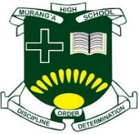
231/ 1 - PHYSICS Paper -1
Time 2 hours

Name …………………………………………….……… IndexNumber………………………….
Candidate’s Signature ………………….…...…….. Date…………………………………………

INSTRUCTIONS TO CANDIDATES
- Write your name, admission number and class in the spaces provided above.
- Sign and write the date of examination in the spaces provided above.
- This paper consists of TWO sections: A and B.
- Answer ALL the questions in sections A and B in the spaces provided.
- ALL working MUST be clearly shown.
- Non-programmable silent electronic calculators and KNEC mathematical tables may be used.
- Candidates should check the question paper to ascertain that all the pages are printed as indicated and that no questions are missing.

For Examiner’s Use Only

Section | Question | Maximum  Score | Candidate’s  Score
A | 1 – 12 | 25
B | 13 | 09
B | 14 | 12
B | 15 | 10
B | 16 | 10
B | 17 | 07
B | Total Score | 80

Turn over

SECTION A (25 MARKS)
Answer all Question in this section in the spaces provided
- Ruiru Boys students are carrying out measurements in order to determine the density of water using two methods. (a) Method 1 Fig. 1.1 shows an empty measuring cylinder on a balance and Fig. 1.2 shows the measuring cylinder containing water.

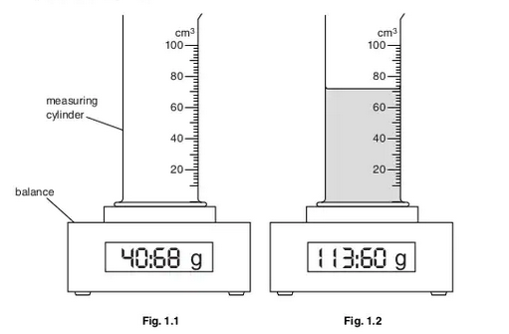

- Read and the following
- Mass of water ………………………………. (1/2 mark)
- Volume ……………………………………… (1/2 marks)
- Hence , calculate the density of the liquid in g/cm³ (1 mark)

- The diagram below show a bottle containing an Orange juice
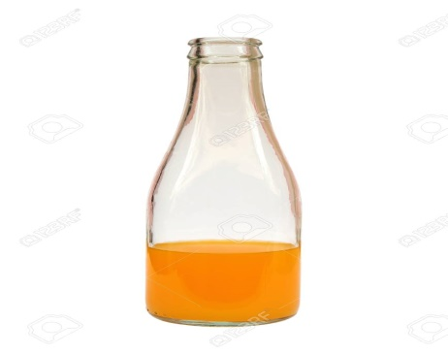

Explain why the bottle when is half-fulled with juice is more stable than a full one or an empty one. (1mark)

………………………………………………………………………………………………………………………………………………………………………………………………………………………………………………………………………………………………………………………………………………
3. Explain why water in a pond may freeze on the surface only but not deep inside the pond. (1mark)
………………………………………………………………………………………………………………………………………………………………………………………………………………………………………………………………………………………………………………………………………………
4. Two ships moving parallel close to each other are likely to collide. Explain (1mark)
………………………………………………………………………………………………………………………………………………………………………………………………………………………………………………………………………………………………………………………………………………
5. Water flows through a tube of length 50cm and of cross-sectional area 50cm2 in 2.5 seconds.
Calculate the rate of flow in cubic metres per second (3 mks)
………………………………………………………………………………………………………………………………………………………………………………………………………………………………………………………………………………………………………………………………………………
- The figure below shows two identical thermometers. Thermometer A has a blackened bulb while thermometer B has a silvery bulb. A candle is placed equidistant between the two thermometers
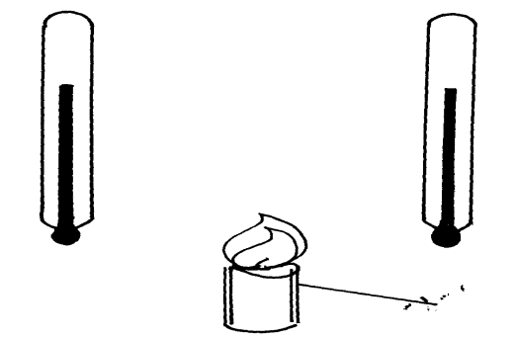
Candle
B
A

State with a reason the observations made after some time (2 mk)
………………………………………………………………………………………………………………………………………………………………………………………………………………………………………………………………………………………………………………………………………………

- Sea water of density 1.04g/cm³ is being pumped into a tank through a pipe of uniformcross-sectional area of 3.142cm². If the speed of water in the pipe is 5m/s, determine the mass flux in S.I unit. (2 mks)
………………………………………………………………………………………………………………………………………………………………………………………………………………………………………………………………………………………………………………………………………………
………………………………………………………………………………………………………………………………………………………………………………………………………………………………

- Explain how the C.O.G of the shape below is found (2mks)

- Two syringes are connected together as shown in the diagram below

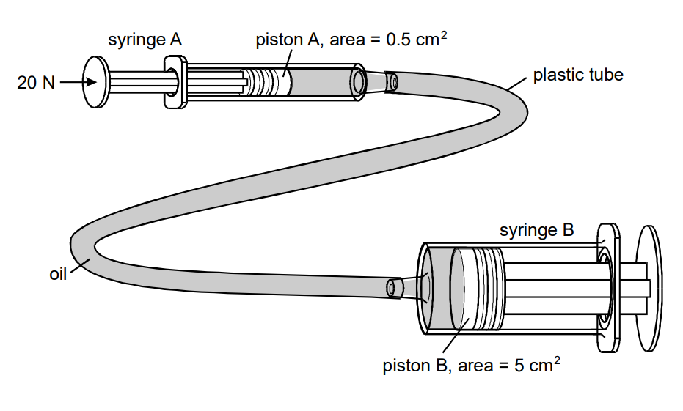
A force of 20 N is applied to the piston in syringe A.
- Calculate the pressure that the piston in syringe A exerts on the oil in SI units ( 1mark)

- Calculate the force needed to just prevent the piston in syringe B from moving out. Give the unit. (1 mark)

- 1 mark A body of mass 6kg and density 8000kgm⁻³ is completely immersed in a liquid of density 900kgm⁻³. Find the upthrust force acting on the body. (2mks)
………………………………………………………………………………………………………………………………………………………………………………………………………………………………………………………………………………………………………………………………………………

- The table below shows results of an experiment carried out to study the properties of a spring

Force (N) added | 0 | 5 | 10 | 15 | 20
Length of spring (cm) | 10 | 11 | 12 | 13 | 14

State with a reason whether the experiment was done within elastic limit of a spring (2mks)
………………………………………………………………………………………………………………………………………………………………………………………………………………………………………………………………………………………………………………………………………………
- It is observed that when an air bubble rises from the bottom of a glass fill with water its size increases. Explain this observation. (2mks)
………………………………………………………………………………………………………………………………………………………………………………………………………………………………………………………………………………………………………………………………………………

- Fifty drops of oil have a volume of 12mm³. One drop of such oil on a water surface forms a film of radius of 1.4cm. Determine the thickness of the film (2mks)
………………………………………………………………………………………………………………………………………………………………………………………………………………………………………………………………………………………………………………………………………………

SECTION B (55 MARKS)
- a) An object is released to fall vertically from height of 100m. At the same time another object is projected
vertically upward with velocity of 40m/s.
(i) Calculate the time taken before the objects meet (3mks)
………………………………………………………………………………………………………………………………………………………………………………………………………………………………………………………………………………………………………………………………………………

(ii) At what height do the objects meet? (2mks)
………………………………………………………………………………………………………………………………………………………………………………………………………………………………………………………………………………………………………………………………………………

(b) A string of negligible mass has a bucket tied at the end. The string is 60cm long and the bucket has a mass of 45g. The bucket is swung horizontally making 6 revolutions per second. Calculate
(i) The angular velocity 2mk)
………………………………………………………………………………………………………………………………………………………………………………………………………………………………………………………………………………………………………………………………………………
(ii) The angular acceleration 2mks)
………………………………………………………………………………………………………………………………………………………………………………………………………………………………………………………………………………………………………………………………………………
(iii)The tension on the string (2mks)
………………………………………………………………………………………………………………………………………………………………………………………………………………………………………………………………………………………………………………………………………………

- The linear velocity (1mk)
………………………………………………………………………………………………………………………………………………………………………………………………………………………………………………………………………………………………………………………………………………

- (a) When is work done? (1mk)
………………………………………………………………………………………………………………………………………………………………………………………………………………………………………………………………………………………………………………………………………………
(b) The table below shows energy conversion from form A to form B and the transduces in use.
Complete the table (5mks)
Form A | Form B | Transducer
Chemical | Electrical | -------------------
Solar | _____________________ | Plants
___________________ | Electrical | Thermocouple
Electrical | Kinetic | __________________
Electrical | ____________________ | Loudspeaker

(c) When an electric pump whose efficiency is 70% raises water to a height of 15m, water is delivered at the rate of 350 litres per minute.
(i) What is the power rating of the pump? (3mks)
………………………………………………………………………………………………………………………………………………………………………………………………………………………………………………………………………………………………………………………………………………

(ii) What is the energy lost by the pump per second. (3mks)
………………………………………………………………………………………………………………………………………………………………………………………………………………………………………………………………………………………………………………………………………………

- (a) Explain why a glass container with thick walls is more likely to crack than one with a thin wall when a very hot liquid is poured into it. (2mks)
………………………………………………………………………………………………………………………………………………………………………………………………………………………………………………………………………………………………………………………………………………

(b) The diagram below shows a circuit diagram for controlling the temperature of a room

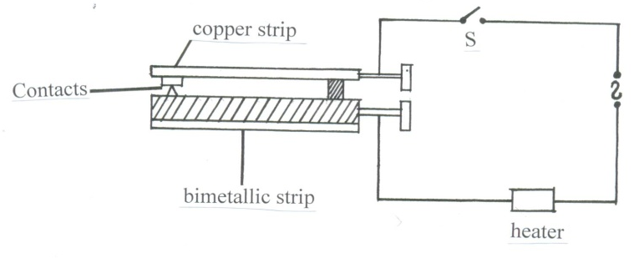

(i) State and explain the purpose of the bimetallic strip (2mks)
………………………………………………………………………………………………………………………………………………………………………………………………………………………………………………………………………………………………………………………………………………

(ii) Describe how the circuit controls the temperature when the switch is closed. (6mks)
………………………………………………………………………………………………………………………………………………………………………………………………………………………………………………………………………………………………………………………………………………………………………………………………………………………………………………………………………………………………………………………………………………………………………………………………………………………………………………………………………………………………

17. a) Explain why water does not get hot in the ocean yet the temperatures around are very high. (2 mks)
………………………………………………………………………………………………………………………………………………………………………………………………………………………………………………………………………………………………………………………………………………

b) State two differences between boiling and evaporation. (2 mks)
………………………………………………………………………………………………………………………………………………………………………………………………………………………………………………………………………………………………………………………………………………

c) A certain powder of mass 0.01kg was heated in a container by an electric heater rated 50W for sometime. The graph below shows the variation of the temperature of the powder with time.
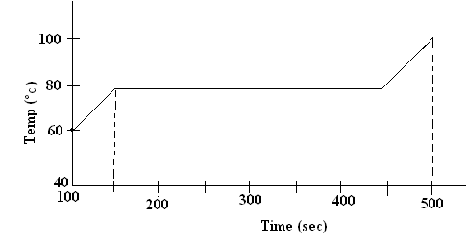
Use the graph to determine
i) Melting point (1 mk)
………………………………………………………………………………………………………………………………………………………………………………………………………………………………

ii) Determine the quantity of heat supplied by the heater from time the powder starts to melt to the time it has all melted. 3 mks)
………………………………………………………………………………………………………………………………………………………………………………………………………………………………………………………………………………………………………………………………………………

iii) Determine the specific latent heat of fusion of the powder assuming the container absorbs negligible amount of water. 2mks)
………………………………………………………………………………………………………………………………………………………………………………………………………………………………………………………………………………………………………………………………………………

- (a) A string of negligible mass has a bucket tied at the end. The string is 600cm long and the bucket has a mass of 45g. The bucket is swung horizontally making 6 revolutions per second. Calculate.

- The angular velocity (3 marks)

ii) The tension on the string. (2 marks)

iii) The linear velocity (2 marks)

b) Sea water of intensity 1.04g/cm³ is being pumped into a pump into a tank through a pipe of uniform cross-sectional area of 3.142 cm². If the speed of water in the pipe is 5m/s, determine the mass flux in S.I unit. (2 marks)

THIS IS THE LAST PAGE PRINTED

