Name: ……………………………………………………………Adm. No. ………………
Stream: ………………………………………. Student’s Sign. ……....
Date: …………………………
233
CHEMISTRY
END TERM TWO 2024
TIME: 2 HOURS

Kenya Certificate of Secondary Education (K.C.S.E)
FORM 1 END TERM TWO EXAM
INSTRUCTIONS TO THE CANDIDATES:-
- Answer all the questions in the spaces provided.
- Write your name and admission number, date in the spaces provided.
- Mathematical tables and electronic calculators may be used for calculation.
- All workings must be clearly shown where necessary
For examiner’s use only:
Question | Maximum score | Candidate’s score
1-16 | 60

This paper consists of 6 printed pages. Candidates should check to ascertain that all pages are printed as indicated and that questions are missing.

- Define the term acid (1mark)
………………………………………………………………………………………………………………………………………………………………………………………………………………………………………………………………………………………………
- Give two examples in each case
- Organic acids …………………………………………………………… (2marks)
…………………………………………………………….
- Mineral acids …………………………………………………………... (2marks)
……………………………………………………………..
- Give three physical properties of acids (3marks)
………………………………………………………………………………………………………………………………………………………………………………………………………………………………………………………………………………………………………………………………………………………………………………………………
- Complete the following word equations (10marks)

Magnesium + Hydrochloric acid
Zinc + Hydrochloric acid
Magnesium + Sulphuric(VI)acid
Sodium carbonate +Hydrochloric acid
Magnesium carbonate +Hydrochloric acid
Sodium hydrogen carbonate +Hydrochloric acid
Sodium oxide + Hydrochloric acid
Sodium hydroxide + Hydrochloric acid
Sodium hydroxide + sulphuric(VI)acid
Magnesium hydroxide + Hydrochoric acid
- Give any THREE examples of commercial indicators (3marks)
…………………………………………………………………………………………………………………………………………………………………………………………………………………………………………………………………………………………………………………………………………………………………………………………........

- Complete the table below (6marks)

INDICATORS | COLORS IN
INDICATORS | Acid | Base | Neutral
Litmus |  |  | Purple
Phenolphthalein |  | Pink
Methyl orange | Pink

- Identify and state the use of the apparatus represented below. (2 marks)
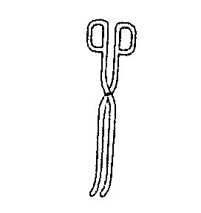
Name……………………………………………………………………

Use………………………………………………………………………

- Classify the process below as chemical or physical changes (4marks)

Process | Physical or chemical change
(a) Fractional distillation
(b) Heating solid wax
(c) Sublimation
(d) Neutralization

- The set-up represented below can be used to separate ethanol from its mixture with water.

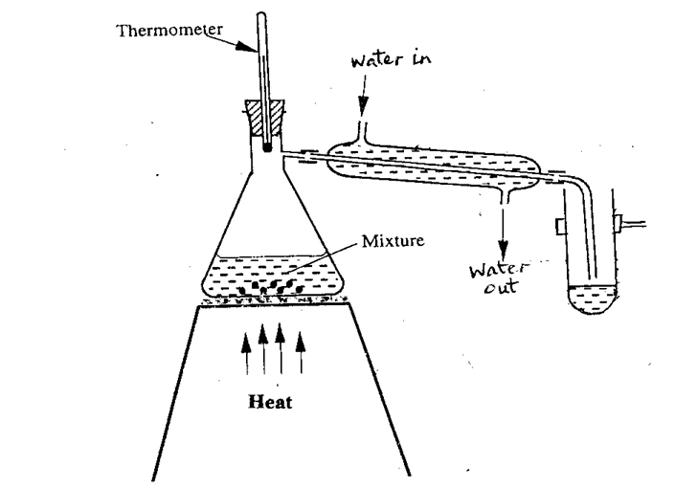
(a) Identify an error in the set-up. (1 mark)
……………………………………………………………………………………………
(b) Name this method of separation. (1 mark)
……………………………………………………………………………………………………
(c) What properties make it possible to separate ethanol from water by this method? (1 mark)
……………………………………………………………………………………………………
……………………………………………………………………………………………………
- The diagram below represents a paper chromatograph of pure A, B, C and D. A mixture of K contains A and D only.

Solvent front
A
C
B
D

A B C D K

- Indicate on the diagram the chromatograph of K (1 mark)
…………………………………………………………………………………………………………………................................................................................................................................................................................

- Label part Z (1 mark)
…………………………………………………………………………………………………………………................................................................................................................................................................................
- Equal volumes of water put in 100cm³ glass beaker and heated for 5 minutes using Bunsen flames. It was observed that water in beaker A registered higher temperature than beaker B.
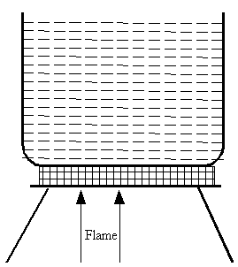

Beaker A Beaker B

- Name the kind of flame used in beaker;
A ........................................................................................................................ (1mark)
- State the condition under which flame that heated B was produced. (1mark)
........................................................................................................................................................................................................................................................................................................................
- a) Give one reason why air is classified as a mixture and not a compound. (1mark)
…………………………………………………………………………….…………………………..…………………………………………………………………………………..………
- An experiment was set up as shown below.
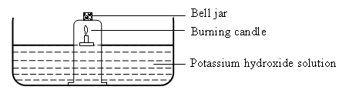
- Why did the candle go off after some time? (1mark)
……………………………………………………………………………………………………….……………………………………………………………………………………….……
- Why was potassium hydroxide used and not tap water? (1mark)
………………………………………………………………………………………………………………………………………………………………………………..……………………………………………
- What is the main component of air in the bell jar at end of experiment? (1mark)
………………………………………………………………………………………………………………………………………………………………………………………………………………
- Classify the following as either compounds or mixtures. (3marks)
 | Substance | Type of substance
(a) | Air
(b) | Salt solution
(c) | Sugar

- Rusting leads to fast wearing out of farm tools and equipment as well as buildings.
  - Give the chemical name of rust. (1 mark)
…………………………………………………………………………………………………………………………………………………………………………
  - What two conditions accelerate rusting process? (2 marks)
……………………………………………………………………………………………………………………………………………………………………………………………………………………………………………………………….

- Give four characteristic of physical changes (4marks)
………………………………………………………………………………………………………………………………………………………………………………………………………………………………………………………………………………………………………………………………………………………………………………………………………………………………………………………………………………………………………………………………………………………………………………………………
- Identify elements present in the following compounds (6marks)
- Lead (II) Oxide ………………………………………………………………………..

- Copper (II)nitrate ……………………………………………………………………….

- Magnesium nitride ……………………………………………………………………

