COMPETENCE BASED CURRICULUM
JUNIOR SCHOOL
GRADE 8
FORMATIVE ASSESSMENT
CREATIVE ARTS

MARKING SCHEME

- Whatsapp
Instagram
Facebook
Youtube
Tiktok
etc
- Art Is a term used to describe skills, feelings and imagination? (1 mk)
- Name two categories of arts.(2 mks)
- Visual arts
- applied arts
- Performing arts
- Written/literacy arts
- State three techniques used in shading a drawing.(3 mks)
- Smudging
- Cross hatching
- Stippling
- Name four elements of an art presentation.(4 mks)
- Speaker
- Audience
- Content
- Resources
- Name two digital devices that can be used when making an art presentation.(2 mks)
- Computers
- Projector
- Radios
- Mobile phones etc
- Write whether the following images are 1D 2D or 3D (3 mks)

3D 2D 1D
- Identify three components of perspective.(3 mks)
- Vanish
- Projection line
- Horizon
- Identify any two types of puppets.(2 mks)
- …………………………………………………….
- …………………………………………………….
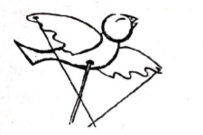
- Name the type of puppet shown below stick or rod puppet(1 mk)
- Name three materials that can be used in crayon etching. (3 mks)
- ……………………………………………
- ……………………………………………
- ……………………………………………
- Decorate the drums below then Shade drawing using any of the three shading techniques.(5 mks)

- What is a colour wheel?(1 mk)
……………………………………………………………………………………………………………………………………………………………………………………………………………………………………
- Identify 2 examples of the following colours in a colour wheel.(4 mks)
Analogous colours | Complementary colours
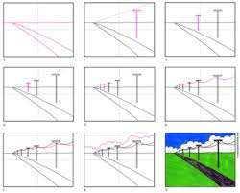
- trace the image below to make it clearer.Using only smudge technique, colour the image.(10mks)

- Complete the following drawing showing the three components of perspective.(3 mks)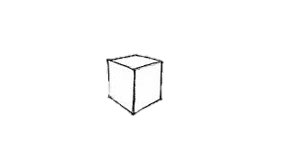
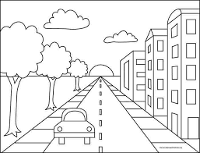
- Below is a sketch drawing. Paint the sketch with appropriate colours making the picture look real.(11mks)

- Name the following types of perspective views. (3 mks)
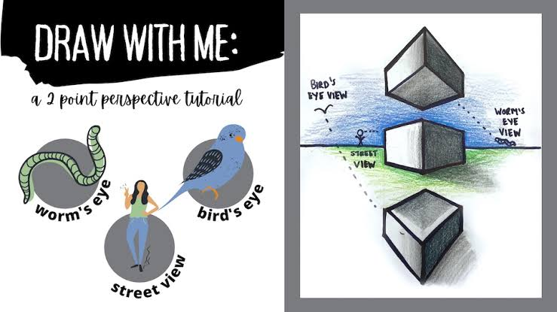
Worms view normal view birds view
- State the kind of view in the following photographs.(2 mks)
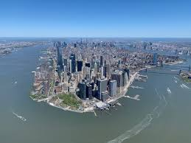
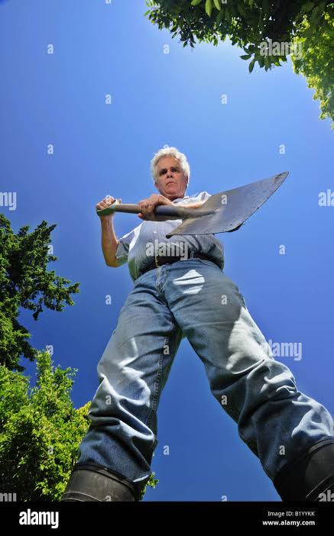

Worms view birds view

- Mix the following primary colours in the circles below and state the colours you get when you mix. (4 mks)
- Blue and yellow=green
- Blue and red = purple/ violet
- Red and yellow = orange
- Red and blue and yellow = grey

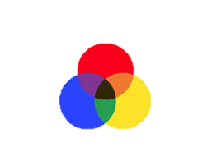
RED
(4 mks)

YELLOW
BLUE

- Name three properties of a colour. (3 mks)
- Hue
- Value
- Intensity
- The picture technique that involves creating a pictorial composition using a collection of pictures is called?collage(1mk)
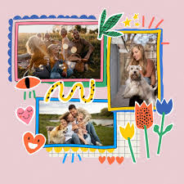
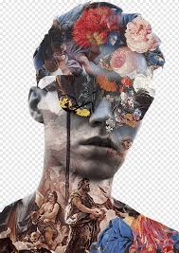
- Name the type of art activity illustrated below(4 mk)

- What is value? (1 mk)
This is the lightness and darkness of a colour
- Use the boxes below to create value gradation.(3 mks)

- What is intensity of a colour? (1 mk)
This is the
- Create intensity scale in the following strip?(3 mks)

- Which colour represents agony or sadness?............................................ (1 mk)
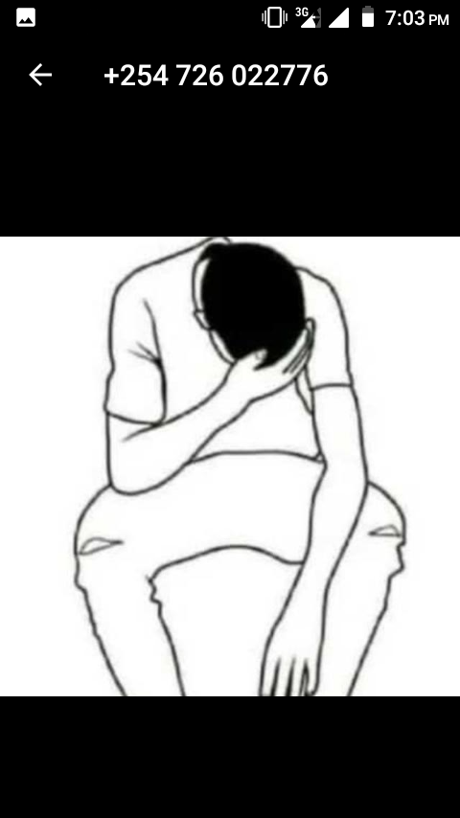
- The image below represents a person who is sad. Use any of the shading technique to show the theme of sadness or agony. ( 5 mks)

- Name three examples of secondary colours. (3 mks)
- ………………………………………………………
- ………………………………………………………
- …………………………………………………….
- In the space below draw a colour wheel.

(5 mks)

THIS IS THE LAST PRINTED PAGE

