COMPUTER STUDIES PAPER 2
TERM 3 2021/2022
NAME_________________________________INDEX NO_______________________________________
SIGN___________________________________DATE__________________________________________
- (a)(i) using a database management system, create a database file named ANTIGUA_ENT_LTD to store the data below 1mk
Commodity Table
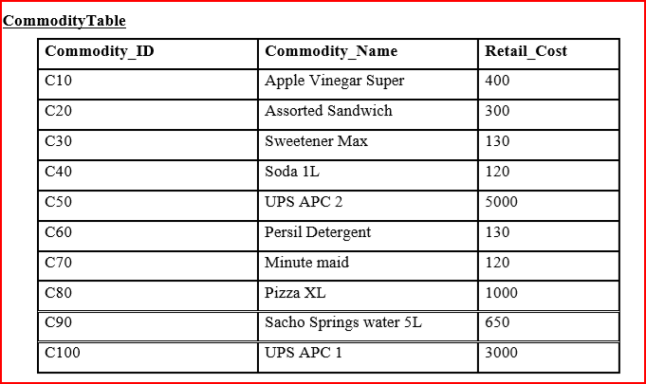
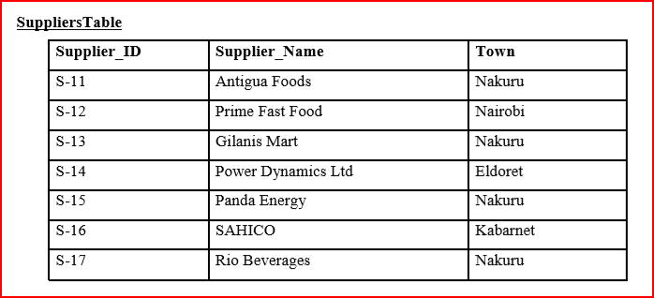
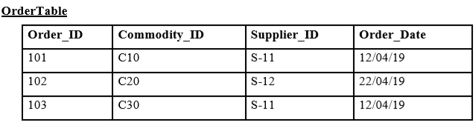
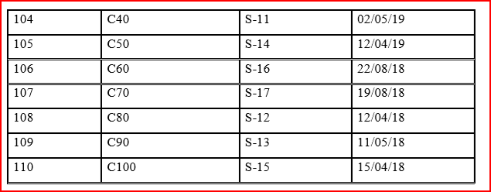

(ii) Create all the above tables in the database created in (a) to store the information above assigning appropriate data types for each of the fields (14mks)
iii) Identify a field to be assigned a primary for each table (1 1/2mks)
iv) Create relationship among the tables and enforce referential integrity (3mks)
(b) Capture number of units for the commodities as shown in the commodity table (3mks)
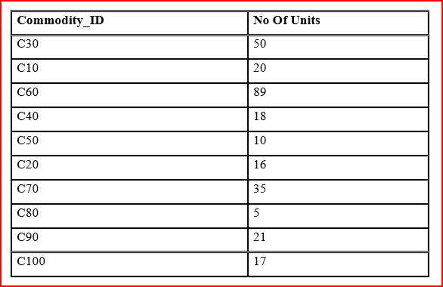
(c) Create a query named RETAILCOST to display commodity name , retail price, number of units, supplier’s name and calculate the total retail price for each commodity 4mks
(d) Create a query named CUSTOM_QR to display name of each commodity , retail price and the number of units ordered . The query should contain commodities whose supplier name start with letter P and total retail price is from ksh 4000 and less than ksh 50000 (5mks)
(e) Create a report named Suppliers RPT to display commodity name, suppliers’ name, total retail price and date of order. (4mks)
- Group records per suppliers’ town
- Title the report as “ANTIGUA SUPPLIERS DETAILS”
- Show the Total Retail Prices per supplier
(f) Create a report Named ORDERS_2019 to display commodity name, retail price, supplier’s name , town and item ordered in the year 2018 only. Show the number of suppliers $3\frac{1}{2} marks$
(g) Create a pie chart to display Total Retail Prices and their respective commodities 2mks
(h) create a form named COMMODITIES_2018 used to enter data in the database to appear as shown below 5mks
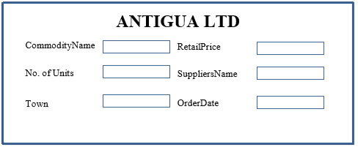

- Print the following ( 4mks)
- Tables: Commodity Table
- Queries: RETAIL_COST and CUSTOM_QR
- Reports : SUPPLIERS_RPT

