NAME……………………….……………………………… INDEX NO.…………………………………

AGORO OYOMBE SECONDARY SCHOOL
COMPUTER STUDIES
PAPER 1(451/1)
2 ½ HOURS

COMPUTER STUDIES PAPER 1
Kenya Certificate of Secondary Education (KCSE)

Instructions to Candidates
- Write your Name, Index number in spaces provided above.
- This paper consists TWO sections.
- Answer ALL questions in section A.
- Answer Question 16 and any other THREE Questions from Section B
- All answers MUST be written in the spaces provided on this question paper.

For Examiner’s Use Only
Questions | Maximum Score | Actual Score
1-15 | 40
16 | 15
17 | 15
18 | 15
19 | 15
20 | 15
TOTAL

SECTION A (40 MARKS)
Answer ALL Questions from this section

- A multi-national company allows employees to telework or work at home and communicate with the office using the Internet. List the hardware, software and services required to access and use the Internet. (3 Marks)

- Mr. Kala wants to buy a printer to use in his automobile workshop for printing sales orders in duplicates. He has approached you for advice.
- What printer should he buy? (1 Mark)

- Give a reason for your answer. (1 Mark)

- Explain why a DVD has a high storage capacity compared to a CD. (2 Marks)

- Using a well labelled diagram, describe the fetch and execute cycle. (3 Marks)

- Explain any two factors to consider when evaluating the suitability of a room for a computer laboratory. (2 Marks)

- Distinguish between OCR and OMR (2 Marks)

- State any two advantages of the artificial intelligence. (2 Marks)

- The word COM appears several times in an essay. Jane would like to change the word to COMPUTER.
    - Advise her on how she can accomplish this task using a word processor. (2 Marks)

    - Differentiate between widows and orphans as used in Word processing. (2 Marks)

- State the functions of the following word processing editing features. (2 Marks)
- Thesaurus

- Grammar checker

- ) Rose wants to send an email to Jack.
- Explain two items that must be present for the mail to be sent. (2 mark)

- (i) Define the term network protocol (1 Mark)

(ii) Name any two examples of network protocols (1 Mark)

- (a) What is the importance of layering in DTP? (1 Mark)

b) Distinguish between column guides and margin guides as used in DTP. (2 Marks)

- Study the work sheet below and answer the questions that follow:

1 | A | B | C | D | E | F
2 | AGORO OYOMBE SEC. SCHOOL
3 | ADM. NO | NAME | MATHS | ENGLISH | AVERAGE | RANK
4 | 1001 | Akinyi | 78 | 85
5 | 1002 | Kamau | 89 | 77
6 | 1003 | Leila | 45 | 46
7 | 1004 | Taita | 67 | 69
8 | 1005 | Mosonytany | 98 | 67
9 | 1006
 | Highest Score
 | Lowest Score
 | Average Score

      - Write a formula that would be entered in cell E4 to compute the average score for Akinyi. (1 Mark)

- Write down a formula that used to return the rank of Leila based on average score. (1 Mark)

- Write down a formula that would return the number of students whose score in English is below 70. (1 Mark)

- The manager of a company wants to improve the security of the computer network. She has decided to use authentication techniques so that employees can identify themselves to the system. Name two authentication techniques and describe how each technique would help keep the data more secure. (3 Marks)

- Mary who works as a systems analyst for JeroKin investments has produced documentation for a newly developed system. State three reasons why both user and technical documentation are needed. (3 Marks)

- Environmentalists plan to test a fast-flowing river for pollution. State two advantages of using a computer to do this rather than doing it manually. (2 Marks)

SECTION B (60 marks)
- (a) Name two different types of loop structure in a typical programming language (1 Mark)
(b) For each loop named in (a) above write a pseudocode to illustrate how ten numbers could be input and their average returned using the named loop.
Type 1 loop ........................................... (4 Marks)

Type 2 loop…………………………………………… (4 Marks)

- A school wants to monitor the number of hours spent by a class of 30 students on the Internet. Using a flowchart write an algorithm which will;
  - for each student, record the times logged on and logged off
  - calculate the length of time each student spends online
  - calculate and output the average length of time per day spent by each student on the Internet.
Assume that a student only logs on and off once a day. (6 Marks)

- (a) Explain three different types of feasibility that system investigation and system analysis must consider. (3 Marks)

(b) (i) State the any two reasons of systems maintenance. (2 Marks)

(ii) State any two activities involved in systems maintenance. (2 Marks)

(c) A shop owner wants to change from a manual stock control system to a computerized stock control system.
  - State three reasons why the shop owner would want a computerized system. (3 Marks)

  - Describe any two methods of fact-finding that would be used to analyze the manual stock control system. (2 Marks)

    - (i) State two types of computer crimes. (1 Mark)

ii)Describe two ways of protecting against computer crime. (2 Marks)

- (a) Draw and label a diagram to show the relationship between a root directory, a subdirectory and a file. (3 Marks)

(b) State three file management tasks that are carried out by an operating system. (3 Marks)

      - Explain how the operating system deals with errors that occur while a program is running. (2 Marks)

(d) One purpose of most operating systems is to provide a human computer interface (HCI). Describe the following HCIs and give an example of an application which would use each:
  - Menu based (1 ½ Marks)

  - Natural language (1 ½ Marks)

(d) In business, a computer user may use two types of application software; general purpose and special purpose software.
(i) Distinguish between the two. (2 Marks)

(ii) An employee uses a special-purpose package. Explain how his subsequent actions will be different from using a general-purpose package. (2 Marks)

- (a) Explain any three methods of representing negative numbers in computers. (3 Marks)

(b) Using 8 bits and twos complement, subtract 3310 from 1210, giving your answer in decimal notation. (3 Marks)

(c) Determine the value of X in the equations:
- 1001101₂ – X₂ = 11010₂ (1 ½ Marks)

- X₂+ 11101₂ = 100₁₀ (1 ½ Marks)

    - (i) Using a well labelled diagram describe timesharing processing mode. (3 Marks)

(ii) State two advantages and two disadvantages of centralized processing mode. (2 Marks)

- (a) A school has a cabled LAN. The head teacher of the school wants to replace it with a WLAN.
- Explain the differences between a cabled LAN and a WLAN. (2 Marks)

- State two advantages and two disadvantages of having a WLAN. (2 Marks)
Advantages
• It is easier to add or remove workstation
• It provides high data rate due to small area coverage
• You can also move workstation while maintaining the connectivity
• For propagation, the light of sight is not required
• The direction of connectivity can be anywhere i.e. you can connect devices in any direction unless it is in the range of access point
• Easy installation and you need don’t need extra cables for installation
• WLAN can be useful in disasters situation e.g. earthquake and fire. People can still communicate through the wireless network during a disaster
• It is economical because of the small area access
• If there are any building or trees then still wireless connection works

(b) Computer networks can be classified according to functional relationships which exist among the network elements. Identify the networks represented below. (2 Marks)
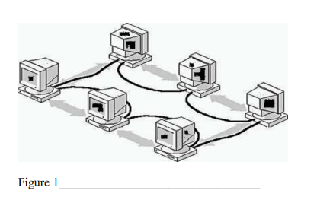
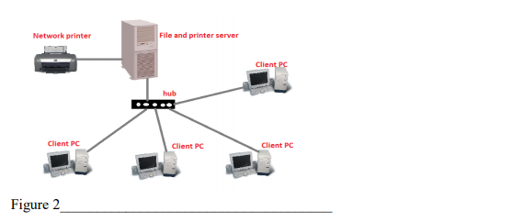

(c) MOKASA library has a file for storing details of the books it has and a file for storing details of its borrowers as shown below. The files are linked using a common field. Use this information to answer the questions that follow.
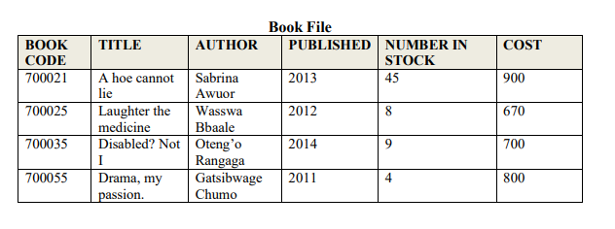
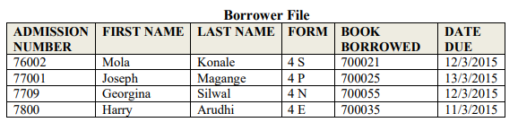
  - How many field values are there in the book file? (½ Mark)

  - What type of database do these two files form? (½ Mark)

  - State two reasons why this type of database system is used rather than having two flat files. (2 Marks)

    - (i) List any four database models. ( 2 Marks)

(ii) Distinguish between a primary key and a foreign key. (2 Marks)

