NAME…………………………………………………………….INDEX…………………………….
SCHOOL………………………………………………………………………………………………

Computer Studies 451/2
COMPUTER STUDIES Paper 2
(PRACTICAL)
2½ hours

COMPUTER STUDIES PAPER 2

Instructions to candidates
- Write your name and admission number at the right hand corner of each print out.
- Write your name and admission number on the CD/removable medium provided.
- Write the name and version of the software used for each question attempted in the answer sheet 4. Answer all the questions
- Passwords should not be used while saving in the CD/removable medium provided.
- All answers must be saved in your CD/removable medium provided.
- Arrange your printouts and tie/staple them together
- Hand in all the printouts and the CD/removable medium used
- This paper consists of 4 printed pages.
- Candidates should check the question paper to ascertain that all the pages are printed as indicated and that no questions are missing

QUESTION 1
  - Create a folder named Harper. Type the document below exactly as it appears using a word processing package and save it as MOCKING_BIRD in the folder created. (8mks)
TO KILL A MOCKINGBIRD
To Kill a Mockingbird is primarily a novel about growing up under extraordinary circumstances in the 1930s in the Soutern United States. In To Kill a Mockingbird, author Harper Lee uses memorable characters to explore civil rights and rasism in the segregated Southern United States of the 1930s.
Told through the eyes of Scout Finch, you learn about her father Atticus Finch, an attorney who hopelessly strives to prove the innocence of a black man unjustly accused of rape; and about Boo Radley, a mysterious neighbor who saves Scout and her brother Jem from being killed.
The Three Most Important Aspects Of To Kill A Mockingbird:
The title of To Kill a Mockingbird refers to the local belief, introduced early in the novel and referred to again later, that it is a sin to kill a mockingbird. Harper Lee implies that it’s unjust and immoral.
The events of To Kill a Mockingbird take place while Scout Finch, the novel’s narrator, is a young child. But the sophisticated vocabulary and sentence structure of the story indicate that Scout tells the story many years after the events described, when she has grown to adulthood.
To Kill a Mockingbird is unusual because it is both an examination of racism and a bildungsroman. Lee examines a very serious social problem. Lee seamlessly blends these two very different kinds of stories.
Unjust &
Immoral

Harper Lee: The Anti-racist

  - Save a copy of the document created above as “MOCKING_BIRD 2” in the folder created in (a) above and use to answer parts (c) to (e). (1mrk)
  - (i) Insert a drop cap to the first letter of the first paragraph, dropping it by two lines. (2mks)
(ii) Apply bullets to the paragraphs under the second heading. (3mks)
(iii) Change the first paragraph under the first heading to three columns. (3mks)
(iv) Format the heading “TO KILL A MOCKINGBIRD” as follows: (4mks)
- Alignment: Right - Font type: Arial black - Font size: 18 - Font style: Underline
(v) Proofread the document to correct spelling mistakes (1mrk)
(vi) Set the page to A4 size, with the following margin specifications: (3mks) - Top: 0.63” - Bottom: 0.6” - Left: 0.6” - Right: 0.63”
(vii) Set the line spacing of the last two paragraphs starting with “To Kill a Mockingbird is unusual...” to 2.0. (2mks)
(viii) Insert a header bearing your name and admission number. (2mks)
(ix) Move the 1st paragraph under the second heading to come below the drawing. (2mks)
(x) Set a hanging indent to the 2nd paragraph which starts with “To Kill a Mockingbird is unusual…” (2mks)
(xi) Replace all words written “racism” with “racial discrimination” (2mks)
(xii) Set the 1st paragraph which starts with “To Kill a Mockingbird is primarily a…” so as the text is aligned to the right. (1mk)
  - Automatically paginate the document using the format “page x of y” (1mk)
  - Apply a page border to the whole document with the following formats: (3mks)
- Style: Double line
- Border color: Blue
- Border width: 2¼pt
  - (i) Create a table at the end of the document created in (b) above and enter the following data (3mks)
BOOK _NO BOOK_TITLE AUTHOR PRICE
B0-02 In Cold Blood Truman capote 875.00
B0-09 Roman Holiday Gregory Peck 955.00
B0-03 The catcher in the Rye J. D. Salinger 650.00
(ii) Insert the title “RELATED BOOK NOVELS” as the first row of the table. Align the title to the center (2mks)
(iii) Apply borders to the whole table (1mk)
(iv) Using a formula, calculate the average cost of books in the table. (2mks)
  - Print the documents; MOCKING_BIRD and MOCKING_BIRD 2 (2mks)

QUESTION 2
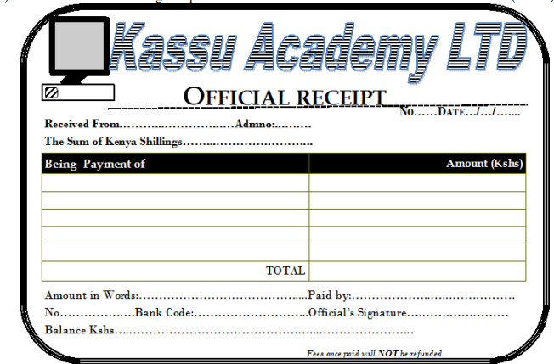
- Use a DTP software to design the publication as shown below (1 mark)

- Prepare the page layout as follows:
- Paper size A4 portrait. (2 marks)
- Set the margins to 0.5 inches all round. (2 marks)
- Divide the page into TWO equal horizontal parts using a ruler. (2 marks)
- (iv) The border should occupy half the page from the margins. (2 marks)
- Create the logo to occupy between 0.8’’ to 1.80’’ left and 0.70’’ to 1.85’’ from top. (9 marks)
- The title should occupy between 1.70’’ to 7.50’’ across and 0.75’’ to 1.45’’ from top. Font Arial black with italics and fill effect pattern of dark horizontal. (7 marks)
- The OFFICIAL RECEIPT should occupy 2.50’’ to 5.70’’ across and 1.50’’ to 2.00 from top. Font Book antique size 26, bold and centered. (4 marks)
- The rest of the text is in font Bodoni MT size 12, except for the footer which is size 9. (9 marks)

  - Align all the text as shown. (2 marks)
  - Group the publication as one. (2 marks)
  - Fit TWO copies of the design into a single page. (1 mark)

- Include a page header with your name, class and index. (4 marks)
- Save as INVOICE. (1 mark)
- Print the publication. (2 marks)

