NAME: ……………………………………… ADM NO: ………..CLASS: ………….
FORM TWO
MATHEMATICS
END OF YEAR EXAMS – 2025
TIME: 2 HOURS

Attempt all the questions in the spaces provided.

1. Two spheres have surface areas of 36cm² and 49cm². If the volume of the smaller sphere is 20.2cm³
calculate the volume of the larger one. (3 mks)

2. Using mathematical tables, evaluate: (4 mks)
5467 x 0.3278
$\sqrt[5]{0.0894}$

3. Simplify the expression below (3 mks)
6b + 2ab – 3a – a²
3a + 2ab – 6b – a²

4. If $4^{3y-4x }$ = 64 and 3^{y} ÷ 9^{x} = 1, solve for x and Y. (3 mks)

5. A straight line passes through point B(-2,1) and C(6,3). Find the equation of a line parallel to BC and passes through a point D(2,4). (3 mks)

6. In the figure below, angle CAB = 27º, angle ABD = 65º and angle DB = 39º. Find the size of angle
CBD. (3 mks)
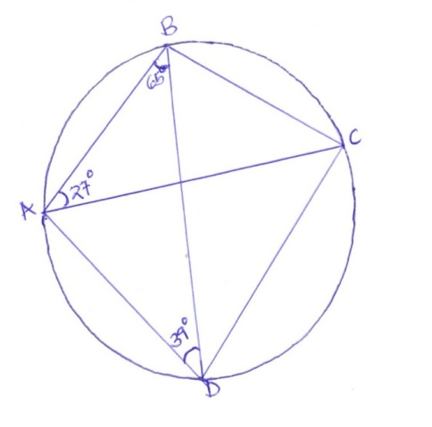
7. Common salt has a density of 2.2g/cm³ while sand has a density of 3.2g/cm3. If 0.8kg of salt is mixed
with 1.5kg of sand, find the density of the mixture. (3 mks)

8. The volume of water in a measuring cylinder is 25.2cm³. After a solid metal sphere is immersed into it,
the measuring cylinder reads 29.4cm³. Calculate the radius of the sphere. (3 mks)

9. Cos Ө = 1 where Ө is an acute angle. Without using mathematical tables, find;
$\sqrt{3}$
(a) Tan (90º – Ө) (1 mk)

(b) Sin Ө in the form $\frac{\sqrt{a}}{\sqrt{b}}$ where a and b are integers. (2 mks)

10. The shaded region in the figure below shows the area swept out on a flat windscreen by a wiper.
Calculate the area of this region. (3 mks)
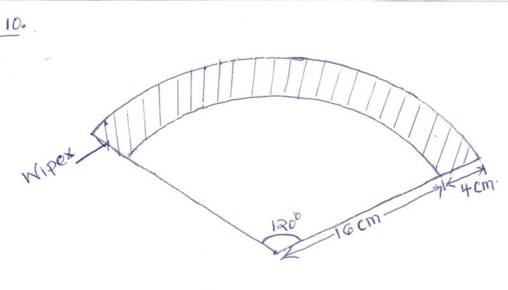

11. A triangular flower garden measures 10m, 15m and 24m. Find the area of the garden. (3 mks)

12. Triangle OAB is such that OA = a and OB = b. C lies on OB such that OC:CB = 1:1. D lies on AB
such that AD:DB = 1:1 and E lies on OA such that OA:AE = 3:1. Find CD in terms of a and b.(3 mks)

13. Giving reasons, find the angle marked b, given that EF is parallel to AC. (3 mks)
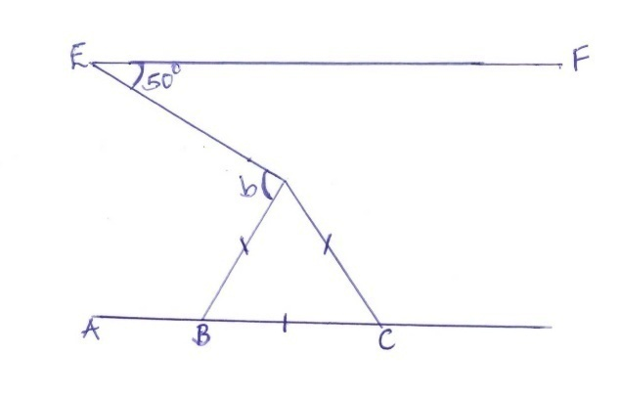

SECTION B: (30 MARKS)
Answer any three questions in this section.
14. The height (in cm) of some seedlings in a nursery are recorded in the table below.

Height (cm) | 1.0 – 1.4 | 1.5 – 1.9 | 2.0 – 2.4 | 2.5 – 2.9
No. of seedlings | 2 | 6 | 4 | 8

(a) State the median class (1 mk)

(b) Calculate the mean height of the seedlings in the nursery. (4 mks)

(c) On the grid provided, draw a histogram and a frequency polygon to represent the information.
(5 mks)

15. On the graph paper provided, plot the triangle whose co-ordinates are A(1, 3) B(2, 1) and C(3, 4). (1 mk)

(a) On the same grid, draw;
(i) A’B’C’ the image of ABC under an enlargement, centre (0,0), scale factor -1 and state its co-
ordinates. (3 mks)

(ii) A”B”C” the image of A’B’C’ under a rotation of +90º about origin. State the co-ordinates of
A”B”C”. (3 mks)
(iii) A’’’B’’’C’’’ the image of A’’B’’C’’ under reflection in the line Y=x and state its coordinates
(3 mks)

16. Three warships P,Q and R leave port X at 9.00 a.m. Ship P sails at a steady speed on a bearing of
070º, 100km from port X while ship Q sails on a bearing of 320º, 80km from port X. Ship R is on a
bearing of 1500 from port X and due south of ship P.
(a) Construct a scale drawing to show the position of P, Q, R and X. (4 mks)

(b) Use the scale drawing to determine:
(i) The distance and bearing of ship P from ship Q. (2 mks)

(ii) The distance of ship R from port X. (2 mks)

(iii) The distance of ship R from ship P. (2 mks)

17. (a) Use a ruler and a pair of compasses only to construct triangle ABC such that AB = 2.5cm, BC =
3.5cm and AC = 5.5cm. Measure < ABC. (3 mks)

(b) Drop a perpendicular from A to a point T on CB produced. Measure the length AT. (3 mks)

(c) With BT as the base, calculate the area of triangle ABT and triangle ACT. (4 mks)

18. The circle in figure below has a radius Xcm and centre O. Minor arc MNP subtends an angle of 156º
at the centre of the circle. Sector MNP has an area of 417.1cm²

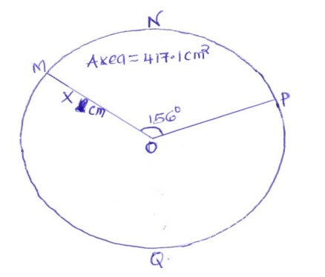

(a) Taking π =$\frac{22}{7}$, find x. (3 mks)

(b) The major sector MQP is obtained from the circle and folded into a cone. Find:
(i) The radius of the cone’s base. (2 mks)

(ii) The height of the cone. (3 mks)

(iii) The surface area of the cone. (2 mks)

